IB Theory of Knowledge

Instructor: Mr., Eric Moore
Email: MooreE@gsis.sc.kr
Website: MrMooreWeb.weebly.com

To raise new questions, new possibilities, to regard old questions from a new angle, requires creative imagination and marks real advances in science.
~Albert Einstein

Course description The Theory of Knowledge (TOK) program is central to the educational philosophy of the International Baccalaureate. It challenges students and their teachers to reflect critically on diverse ways of knowing and areas of knowledge, and to consider the role which knowledge plays in a global society. It encourages students to become aware of themselves as thinkers, to become aware of the complexity of knowledge, and to recognize the need to act responsibly as global citizens in an increasingly interconnected world.

As a thoughtful and purposeful enquiry into different ways of knowing, and into different kinds of knowledge, the TOK program is composed almost entirely of questions that pertain to knowledge issues. The most central of these questions is 'How do I, or how do we, know that a given assertion is true, or a given judgment is well grounded?' Assertions or judgments of this sort are termed 'knowledge claims', while the difficulties that arise in addressing these questions are the broad areas known as 'knowledge issues'. The program entails the application of this central question to many different, yet interrelated, real life situations.

Questions are the very essence of TOK, both ageless questions on which thinkers have been reflecting for centuries and new ones, often challenging to accepted belief, which are posed by contemporary life. Students will foster an appreciation of the quest for knowledge, in particular its importance, its complexities, and its human implications.

While taking TOK, students should reflect upon how the issues and concerns examined in this class are pertinent to the other aspects of the IB Diploma, including CAS and the various subject groups.

Aims

The aims of the ToK course are to:

- Develop a fascination with the richness of knowledge as a human endeavour, and an understanding of the empowerment that follows from reflecting upon it
- Develop an awareness of how knowledge is constructed, critically examined, evaluated and renewed, by communities and individuals
- Encourage students to reflect on their experiences as learners, in everyday life and in the Diploma Program, and to make connections between academic disciplines and between thoughts, feelings and actions
- Encourage an interest in the diversity of ways of thinking and ways of living of individuals and communities, and an awareness of personal and ideological assumptions, including participants’ own
- Encourage consideration of the responsibilities originating from the relationship between knowledge, the community and the individual as a citizen of the world.

Objectives

Having followed the TOK course, students should be able to:

- Analyse critically knowledge claims, their underlying assumptions and their implications
- Generate questions, explanations, conjectures, hypotheses, alternative ideas and possible solutions in response to knowledge issues concerning areas of knowledge, ways of knowing and students’ own experience as learners
- Demonstrate an understanding of different perspectives on knowledge issues
- Draw links and make effective comparisons between different approaches to knowledge issues that derive from areas of knowledge, ways of knowing, theoretical positions and cultural values
- Demonstrate an ability to give a personal, self-aware response to a knowledge issue
- Formulate and communicate ideas clearly with due regard for accuracy and academic honesty.

Topics of Study in Years 1 and 2:
*Note that the goal of the course is to ensure that the ideas and knowledge issues presented in Theory of Knowledge are understood by the student to be related to real life situations. Thus, while each of the units presented below deals with a specific topic, student will be asked to examine contemporary happenings and their connection to TOK from the beginning of the class in order to make the class more relevant. Assessments are in bold at the end of each semester.

The course will follow a gradually expanding study ranging from an self-awareness of the students as individual “knowers” to an exploration of different ways that they come to know information, developing into a study of the ways we categorize knowledge into various areas of study, and ultimately culminating in an ability to effectively explore any situation, statement, or expressed belief using these aspects. This is reflected in the ToK Diagram (below).

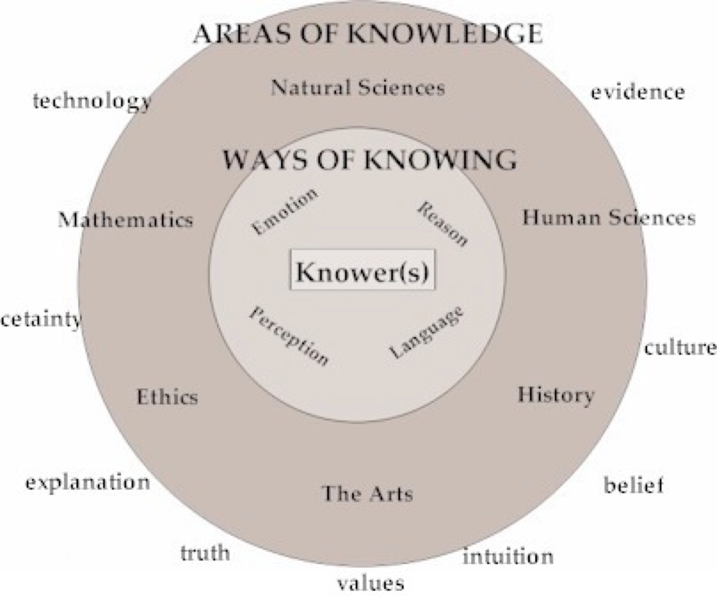

Year One:

- The individual as a knower, knowledge issues
  - What is knowledge? Truth? Belief? Faith? What are the differences between these concepts?
  - How does one justify a belief?
  - Truth tests
- Ways of knowing
  - Perception
  - Language
  - Logic
  - Emotion
  - Faith

- Areas of Knowledge
  - Art

*Summative Assessments: Oral Presentation + Practice Essay

Year Two:

- Areas of knowledge
  - Ethics
  - Human Science
  - Natural Science
  - History
  - Math
*Oral Presentation (redo, if necessary) + Essay

**IB Prescribed Title Essay (Rough draft due Wednesday, November 20, 2011; final draft due before Christmas Holiday!)

Assessment: The major summative assessments for this course will be the IB internal and external assessment. These will be used to determine the students’ FINAL grade (post-graduation), but their GSIS grade will be determined exclusively by formative and in-class assessment and participation for the first year, and by these plus IA score and essay predicted grade for Semester 3.

1. External Assessment (40 points)

- Students will submit a 1200-1600 word essay on one of ten prescribed titles. The IB (not the teacher) will use criteria-based assessment to determine the student’s final score.
- The essay rough draft is due November 20; final draft due before you leave for Christmas break) – put these dates in your calendar TODAY and plan ahead.

2. Internal Assessment

- Students must do either an individual or small group (3 maximum) performance exploring a knowledge issue that relates to a real-life situation.
- Each individual student will be allocated 10 minutes, up to a maximum of 30 minutes per group.
- The teacher will use the four assessment criteria provided by the IB to determine the student’s final grade.
- This assessment will occur at the end of year 1. If students are unsatisfied with their grades, they may opt to redo at the end of the first quarter of year 2.

3. Non-IB assessment

These assessments will constitute the formative assessments for the class. Students will demonstrate their understanding of the material through personal journals, class participation, quality of analysis, critical thinking, the ability to examine issues from multiple perspectives, and the ability to support their ideas with examples and evidence. Students will be expected to come prepared to engage the materials daily.

Students will also have various written assignments to demonstrate their understandings of the course material. They will also be expected to do, in addition to the formal IB presentation, at least short oral presentation on a knowledge issue.

Class members will also be expected to respond to blog entries and prompts posted by the teachers relating to knowledge issues embedded in real life situations.

GSIS GRADE | A majority of the course will be graded on the attached rubric (approximately 75%).  The remaining 25% of the grade will be comprised of various written and oral assignments that are graded based on the IB TOK criteria.

Assessment Rubric

A | - Student always or almost always comes to class with all necessary materials.  - Student journal, blog responses, and other written reflections are maintained and kept up to date on a daily basis. Entries are thoughtful and thorough, and raise questions based on readings, class discussions, and contemporary issues relevant to the student.  - Student participation in classroom discussion is frequent, considered, respectful, and appropriate.  - Quality and level of thinking demonstrates exceptionally clear understanding, analysis, and the ability to consider multiple perspectives.  - Student always uses relevant and sufficient evidence to support claims. Generalizations or abstractions are always supported by specific or concrete examples, consistently reflecting both the student’s own unique perspective and a recognition of a global perspective  - Students show great skill in recognizing the knowledge issues embedded in real life situations.  - Students make effective linkages between the various areas and ways of knowing
B | - Student usually comes to class with all necessary materials.  - Student journal, blog responses, and other written reflections are well-maintained and kept up to date on a regular basis. Entries are thoughtful and thorough, and raise questions based on readings and class discussions.  - Student participation in classroom discussion is regular, considered, respectful, and appropriate.  - Quality and level of thinking demonstrates clear understanding, analysis, and the ability to consider multiple perspectives.  - Student usually uses relevant and sufficient evidence to support claims. Generalizations or abstractions are usually supported by specifics or concrete examples, consistently reflecting both the student’s own unique perspective and a recognition of a global perspective  - Students show competency in recognizing the knowledge issues embedded in real life situations  - Students often make effective linkages between the various areas and ways of knowing
C | - Student is inconsistent in coming to class with all necessary materials.  - Student journal, blog responses, and written reflections are maintained inconsistently. Entries demonstrate a lack of consistent or considered thought and may be spotty or brief. Questions are asked but are at times superficial or lacking in seriousness.  - Student participation in classroom discussion is inconsistent and occasionally lacking in appropriateness or consideration.  - Quality and level of thinking demonstrates rudimentary understanding and the student has difficulty considering more than one or two perspectives.  - Student occasionally uses relevant and sufficient evidence to support claims. Generalizations or abstractions are occasionally supported by specifics or concrete examples, occasionally reflecting both the student’s own unique perspective and a recognition of a global perspective  - Student shows inconsistency in recognizing the knowledge issues embedded in real life situations  - Students occasionally make effective linkages between the various areas and ways of knowing
D | - Student comes to class with all necessary materials only occasionally.  - Student journal entries, blog responses, and other written responses are poorly maintained and/or not kept up to date. Entries lack serious thought and reflection.  - Student participation in classroom discussion is infrequent and lack consideration, respect, or appropriateness.  - Quality and level of thinking demonstrates insufficient understanding, analysis, and the inability to consider multiple perspectives.  - Student uses irrelevant or insufficient evidence to support claims. Generalizations or abstractions are rarely supported by specifics or concrete examples, rarely reflecting both the student’s own unique perspective and a recognition of a global perspective  - Student shows very limited ability with regard to recognizing the knowledge issues embedded in real life situations  - Students seldom make effective linkages between the various areas and ways of knowing
F | - Student rarely comes to class with all necessary materials.  - Student journal, blog responses, and other written reflections are not maintained or kept up to date on a daily basis. Entries are elementary or superficial; student does not bother to raise questions for consideration.  - Student participation in classroom discussion is infrequent or absent, random, disrespectful, or otherwise inappropriate.  - Quality and level of thinking demonstrates muddled thinking or lack of understanding and the inability to consider more than one perspective.  - Student rarely or never uses relevant or sufficient evidence to support claims. Generalizations or abstractions are unsubstantiated.  - Student shows no ability with regard to recognizing the knowledge issues embedded in real life situations  - Students never make effective linkages between the various areas and ways of knowing

Academic Integrity
This course, as with all courses at GSIS, places high expectations on the students in terms of academic integrity and honesty at all times. Students will be responsible for completing their work personally, and may not at any time submit work that has been completed in part or in whole by another person. This means that all quotations and paraphrasing, when appropriate, must be documented in accordance to the rules of MLA citations. If there are any questions, students are expected to ask before submitting work. Any infringement of the Academic Integrity policy will be followed up with to the full extent of the GSIS policy, as stated in the student handbook.

Final Thoughts
As the teacher of this course, I pledge to give each student every opportunity to grow academically, socially, and spiritually for the duration of the time I have him or her. Students and parents are encouraged to contact me via email if there are any questions or concerns at any time, and I will do my all to respond in a timely manner. I am excited to be working in this course, in Korea, and with these students. God bless!

