MYP English Language A, Grade 9

Instructor: Mr, Eric Moore
Email: MooreE@gsis.sc.kr

There’s some good in this world… and it’s worth fighting for.
~J.R.R. Tolkien, Lord of the Rings

Course description and expectations:

The MYP English 9 course is designed to build on the foundation of English education, which you have received up to this point in your time in school. In this course, we will push further and explore deeper into literature than you ever have before, as we go beyond simply identifying “what” the text says and means, to explore what the significance, impact, or purpose of a text may be.

MYP English 9 and 10 are designed in such a way as to develop the skills and knowledge that you will need to be maximally successful in the IB Diploma Program in grades 11 and 12. To this end, we will be exploring four (4) major units this year; each is designed to expose you to a different type of text and context and to develop specific skills of analysis, appreciation, and response.

Furthermore, English 9 – and all subjects at GSIS – is designed to create holistic growth in you, our students. Certainly developing your academic skills, but also sharpening your spiritual development, emotional awareness, social inclusion, and ethical alertness such that you will know how to apply the knowledge you gain in ways that serves others and honor God.

It is important to realize that English 9 is both independent and part one of a two-part course, continuing into grade 10. It is also important that you, the student, intentionally focus on making connections between this course and your other MYP courses, by content, activities, and areas of interaction. The more connections you can make independently, the better!

In this course, you will be challenged to push yourself, and will be given every opportunity to succeed. I expect that you will believe in yourself, respect your teacher, your peers, and the environment we share, and that you will be inquisitive and active participants in the learning process. This is a journey we’re on together – give it you all!

Units of Study:

Human Ingenuity: Adventures in Short Stores – We will explore a variety of short stories to develop awareness and appreciation of literary devices and tools that are used in the art of literature, and begin exploring why these devices are used and what effect they have on a given text.

Health and Social Education: Exploring Shakespearian Tragedy through Romeo and Juliet – This classic story of “star-crossed lovers” will give us an opportunity to have an early exposure to Shakespeare and 17th century English. We will also raise discussion on such topics as fate, love, sacrifice, honesty, family ties, and reconciliation.

Human Ingenuity: The Epic Journey of Odysseus and the Hero’s Journey Archetype – This unit will enable us to structure all human stories in one framework. This will enable you to apply the framework to your own life story and begin to see where you are on various quests in your life. Odysseus will give us access to mythology and poetry and will raise themes of courage, heroism, cultural values, faithfulness, ancient religion, and “true myths”.

Environments: Lord of the Flies William Golding’s classic story of marooned British school boys on a deserted island will challenge us to explore Golding’s and our own perspective on the human condition and the role that we play in shaping our environments for better or worse.

Course Aims and Objectives:
The MYP manual gives these aims for Language A:

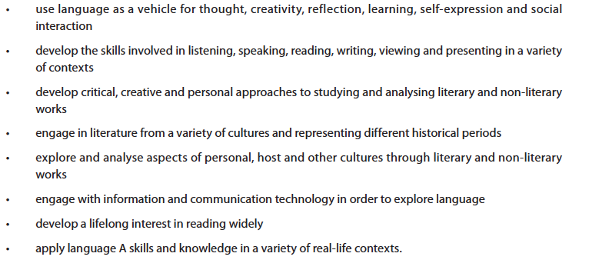

There also, we can find the course objectives – which correspond to the assessment criterions:

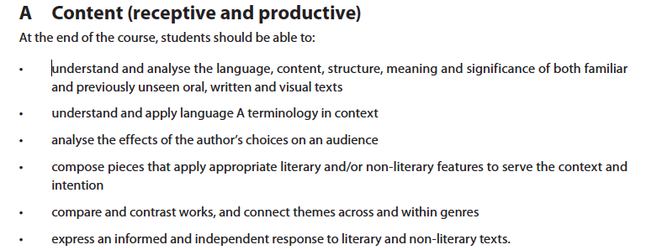

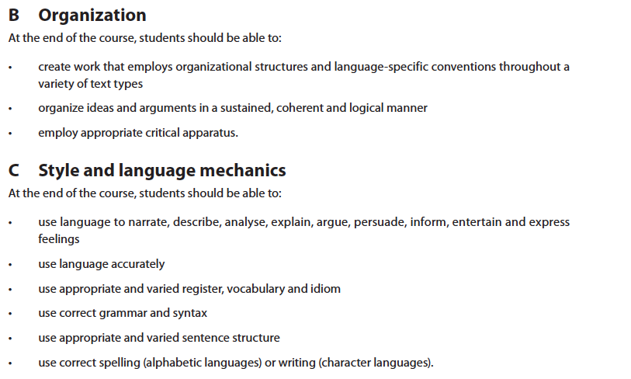

Assessments
A variety of formative assessments will occur daily. Though these will not count toward your final grade, they must be completed for you to gain the benefit for which they are intended. Failure to complete assigned work on time will result in detentions given in order to ensure that you finish the said work and – therefore – gain the benefit thereof.
- Homework
- Class discussion
- Class activities and projects
Summative assessments will occur at least once per quarter. Each summative assessment will have a corresponding rubric, which will be given to you in advance. The summatives will focus on the objectives listed above, and will call for you to demonstrate your current level of mastery in these objectives.

Academic Integrity
This course, as with all courses at GSIS, places high expectations on the students in terms of academic integrity and honesty at all times. Students will be responsible for completing their work personally, and may not at any time submit work that has been completed in part or in whole by another person, including a tutor (학원). This means that all quotations and paraphrasing, when appropriate, must be documented in accordance to the rules of MLA citations (once taught – until then, find some way of clearly stating that you have used a source other than your own brain when applicable). If there are any questions, students are expected to ask before submitting work. Any infringement of the Academic Integrity policy will be followed up with to the full extent of the GSIS policy, as stated in the student handbook.

Final Thoughts
As the teacher of this course, I pledge to give each student every opportunity to grow academically, socially, and spiritually for the duration of the time I have him or her. Students and parents are encourage to contact me via email if there are any questions or concerns at any time, and I will do my all to respond in a timely manner. I am excited to be working in this course, in Korea, and with these students. God bless!

